Mark Skidmore/Guilherme Martins

CS302 Data Structures
Fall 2008 - Dr. George Bebis

Programming Assignment 5
Extra Credit
Due Date: 12/4/2008

I. Introduction

The primary purpose of this program is to demonstrate the use of a Binary Search Tree (BST). User IDs and corresponding passwords will be read from and stored in a BST. A menu system will allow the user to perform elementary operations on the tree as demonstrated below in the following section.

II. Program Usage

The program is simple to use. In a command window, navigate to the 5Assignment/ExtraCredit folder containing the program files. Then from the command line, simply run the executable by typing ./bst.bin and follow the on-screen prompts and menu as shown below in Illustration 1. Upon opening of the program, a text file containing userIDs and passwords, is read into and populates a BST. The user can choose any of the menu items.

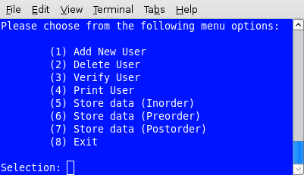Illustration 1: BST Menu Choices

Illustration 2 shows a user being added to the BST. But because the user already exists, the userID is not allowed to be entered. The second attempt shows a new user being added.
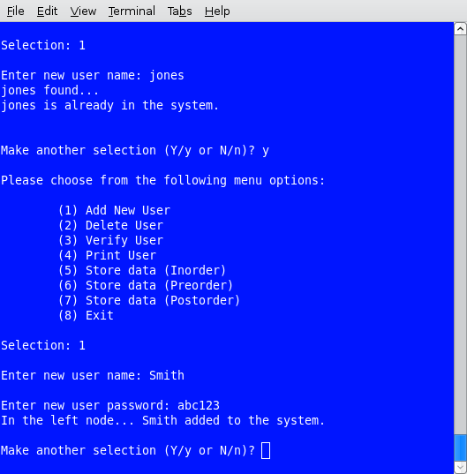Illustration 2: BST Menu Item 1

Illustration 3 shows a user being deleted from the BST. But because the user does not exist, the userID is not found. The second attempt shows a user being deleted.

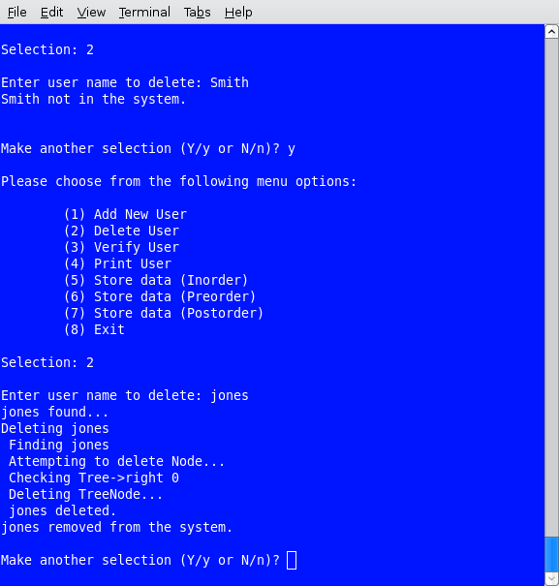Illustration 3: BST Menu Item 2

Illustrations 4 through 7 show the contents of the BST printed to the screen in inorder (ill. 4 and 5), preorder and postorder order, respectively. Although not shown, menu items 5 through 7 also write the respective list to a file. See the program folder for verification.

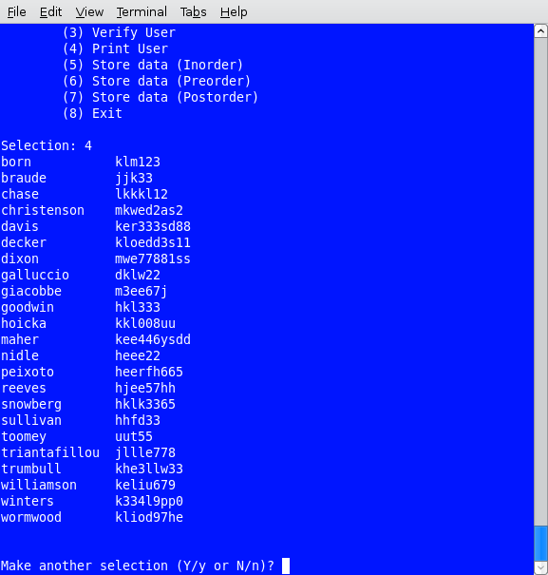Illustration 4: BST Menu Item 4 – inorder traversal

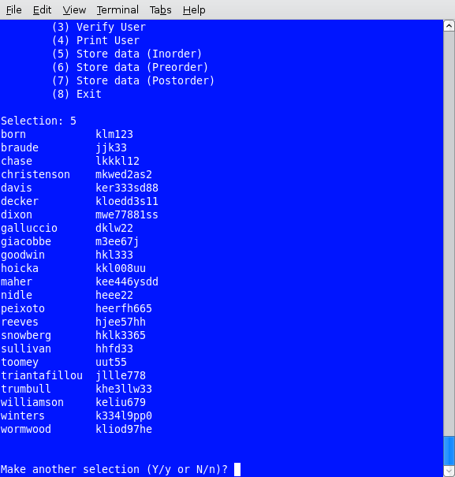Illustration 5: BST Menu Item 5 – inorder traversal with print

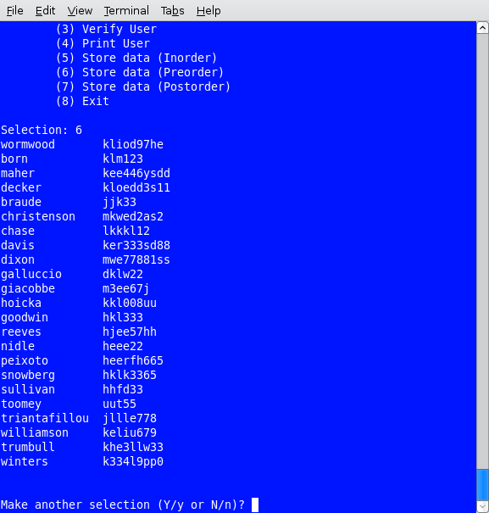Illustration 6: BST Menu Item 6 – preorder traversal with print

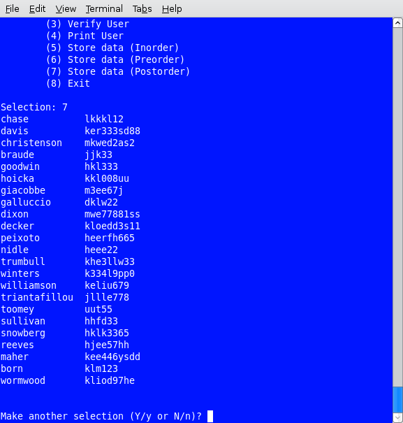Illustration 7: BST Menu Item 7 – postorder traversal with print

Illustration 8 below shows the termination of the program.
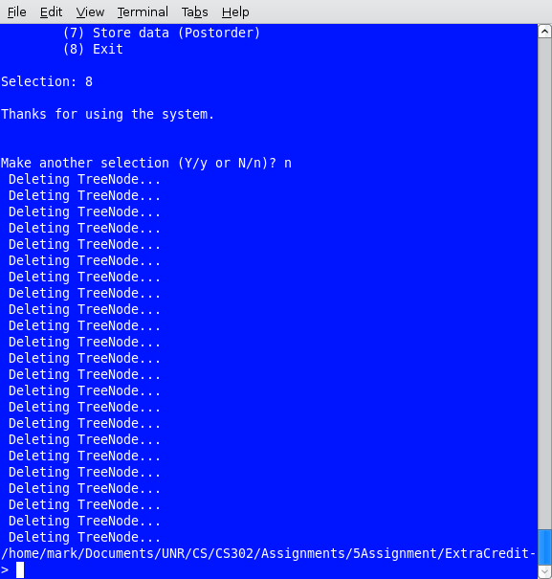Illustration 8: BST Menu Item 8

III. Program Implementation and Results

A. BSTmain.cpp Client Functions

BSTmain.cpp is the main driver for the program and uses the TreeType class which in turn uses the TreeNode class.

void populateBST(TreeType&);

Called from within main; calls openFile() function which opens a text file then reads two strings (userID and password) items from the file and inserts them in the main instantiated TreeType object, BST. Closes the openFIle() function.

void openFile(ifstream &fin, char *textFile);

Called from within populateBST(); opens a text file using the ifstream object, fin, and a text file name stored in textFile.

int displayMenu();

Called from within main; displays a list of menu items to the user. Returns an integer indicating the user's choice of which menu item to execute.

int validateChoice(int choice);

Called from within displayMenu() function to validate user's choice of menu items. Ensures user enters valid menu item number. Returns the integer indicating the user's choice of which menu item to execute.

char validateResponse();

Validates the user's input to the displayMenu() function. Returns Y/y or N/n char to indicate user's choice to continue program usage (Y/y) or termination (N/n).

void executeCases(TreeType&, int);

Called from within main and remains active until the user chooses to exit. Accept and passes the user's choice (1 through 8) returned from displayMenu() and a main-declared and populated TreeType object to the executeCases() function for further user-selected processing.

B. The TreeType Class (TreeType.h/.cpp)

This class contains standard Binary Search Tree functions and are briefly described below. Note: Only those functions used in the TreeType class are described here.

TreeType();

Default constructor; Called when a TreeType object is instantiated.

void InsertItem(string userID, string pWord);

Called from within main when menu item 1 is chosen. Inserts a user ID and corresponding password into the BST object based on string value of userID. Uses the FindNode() function to place a new node in its correct position in the tree.

void DeleteItem(string userID);

Called from within main when menu item 2 is chosen. Calls utility recursive function DeleteNode() and utility Delete() and GetPredecessor() functions to locate and delete correct node.

void PrintPre (std::ofstream& fout) const;
void Print (std::ofstream& fout) const;
void PrintPost(std::ofstream& fout) const;

Called from within main for cases 4, 5, 6 and 7, case 4 display to the screen an alphabetical listing of the userIDs and corresponding passwords to the screen. Case 5, 6 and 7 display and write an alphabetical (inorder), preorder and postorder listing, respectively, of userIDs and corresponding passwords. Each respective Print() (pre, in or post-order) function calls respective PrintTree() (pre, in or post-order) recursive function.

~TreeType();

Class destructor. Deletes left nodes, then right nodes then the tree.

C. The TreeNode Class (TreeNode.h/.cpp)

The TreeNode Class is used by the TreeType class to instantiate new nodes and hold userID and password values. Functions are described below.

TreeNode();

Default constructor; called when a TreeType object is instantiated with no parameters.

TreeNode(string, string);

Accepts and sets userID and passWord to passed in values; also sets left and right members to NULL. Called when a TreeType is instantiated with two string parameters.

~TreeNode();

Default Destructor; called when a TreeType object goes out of scope or when the program closes.

D. Results

The program performs as required. The program is for use with two string data types (userID and password) only and assumes the user will use a text file containing two columns of userIDs and corresponding passwords to populate a binary search tree. Also, the text file must be named “UIDPwords.txt.” Although not required, case 4 additionally writes an inorder text file. Case 5, 6 and 7 write hard coded file names “inorder.txt”, “preorder.txt” and “postorder.txt”, respectively.

IV. Bugs and Errors

Although no bugs or errors are noted as of this release, we do note that there is no control to ensure a perfectly balanced binary tree any time a list is retrieved and inserted. For example, If userIDs are stored in alphabetical order, then upon retrieval and insertion, a simple linked list will result. In order to determine if the tree was storing userIDs in binary fashion, we randomly re-ordered the userIDs and observed the insertion process. It appeared items were being inserted according to the binary search property and preorder, inorder and postorder displays also appeared to work correctly.

Also, when adding a new user, the program does not allow a user with the same name to be added twice. In addition, in order to update a password, the existing userID must be deleted then re-added with the new password.

VII. Partner Contributions.

Both partners contributed 50% each to the assignment.

